**Human Resources Issues**

Human resources is used to describe both the people who work for a company or organization and the department responsible for managing resources related to employees

**Aim of HRM**

•The cost of recruiting new staff is high and the loss of continuity when staff leave can also be very expensive.

•Accordingly, the organization will want to keep staff turnover low.

•Many organizations want to behave as a ‘good’ employer and will therefore try to follow the best of current employment practice.

•This is true specially in the IT industry, where staff have high expectations and staff turnover is particularly high

**Recruitment and selection…**

Recruitment is the process of soliciting applications for jobs. It is often handled partly or entirely by consultants. Selection is the process of selecting from the available applicants.

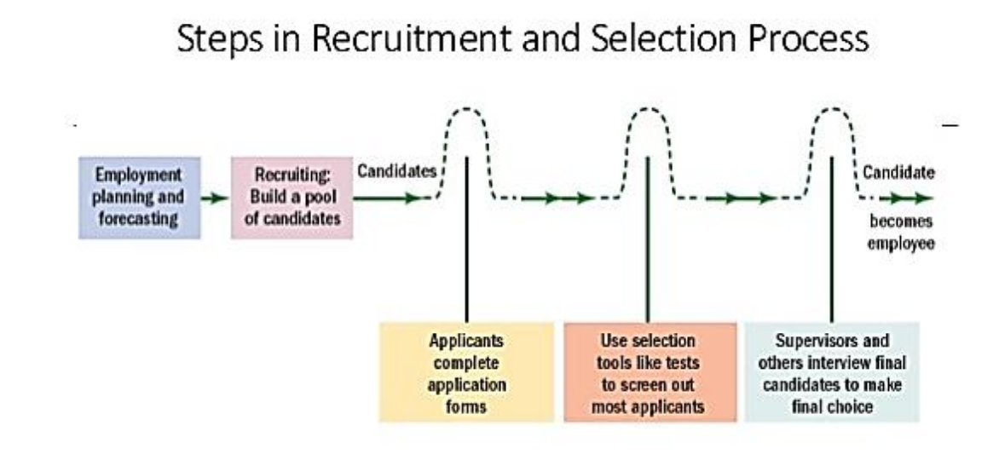

Steps in the recruitment process:

Job analysis is totally about finding out the everything about what job involves by identifying the following.

* Tasks to be completed in the job
* Responsibilities in the job
* Technology that is used in the job
* Knowledge needed carry out the job
* Skills needed to carry out the job
* Level of initiative needed from staff

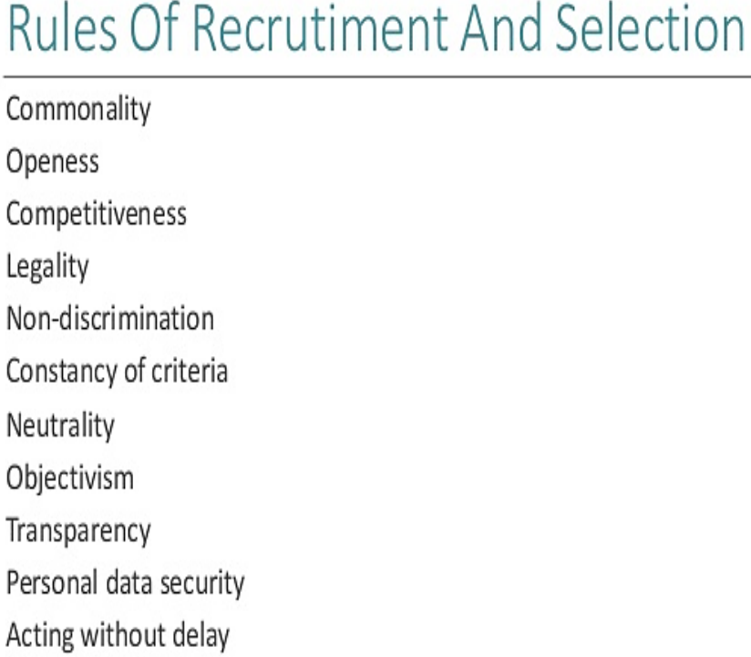

**Advertisement**

Two types:

**1:** Blind add

**2:** Effective add

**Other Methods**

A) private employment Search Firms B) Employment Exchanges C) Gate Hiring & Contracting

D) Unsolicited Applications / Walk-ins E) Internet recruiting F) Raiding G) Nepotism: Hiring relatives.

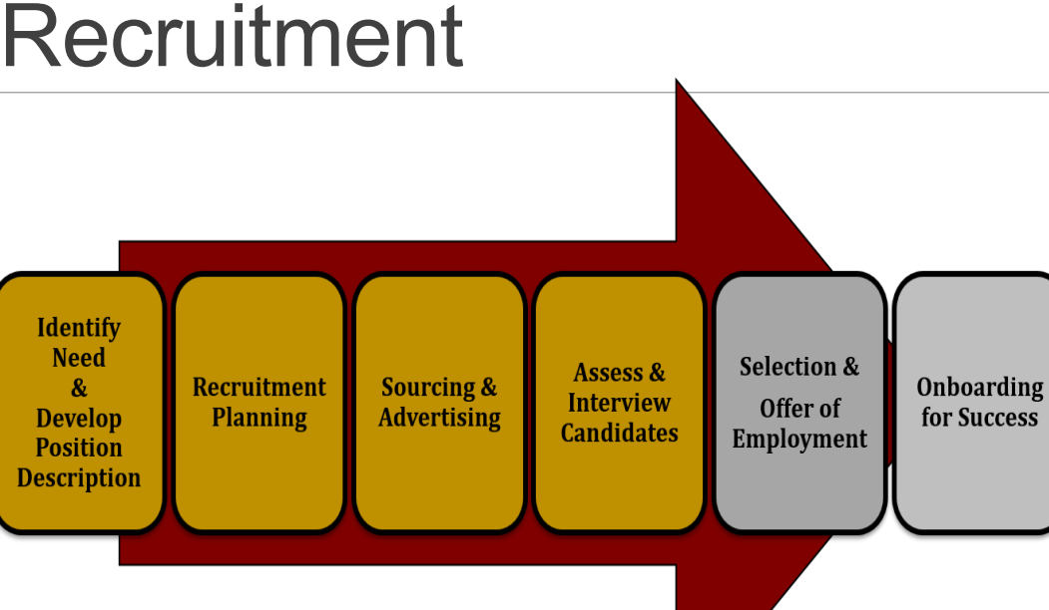

**Selection techniques**

Following are some of the selection techniques used in making professional appointments:

* One-to-one interviews with several senior managers and technical staff
* Interview by a panel
* Assessment of references
* Aptitude tests
* Situational assessment
* Task assessment

**Selection Process:**



**Redundancy and dismissal**

**Redundancy** occurs when staff are fired because there is insufficient work for them. They may be eligible for compensation where as **Dismissal** means firing staff because their work is unsatisfactory.

**Following are the dismissal procedures:**

* employer must give employee a written statement of why dismissal is being considered;
* employer must arrange a meeting at which both sides can state their case;
* employer must inform employee of decision, in writing;
* employee must have right to appeal to a more senior manager, where this is practicable.

**Human Resource Management System**

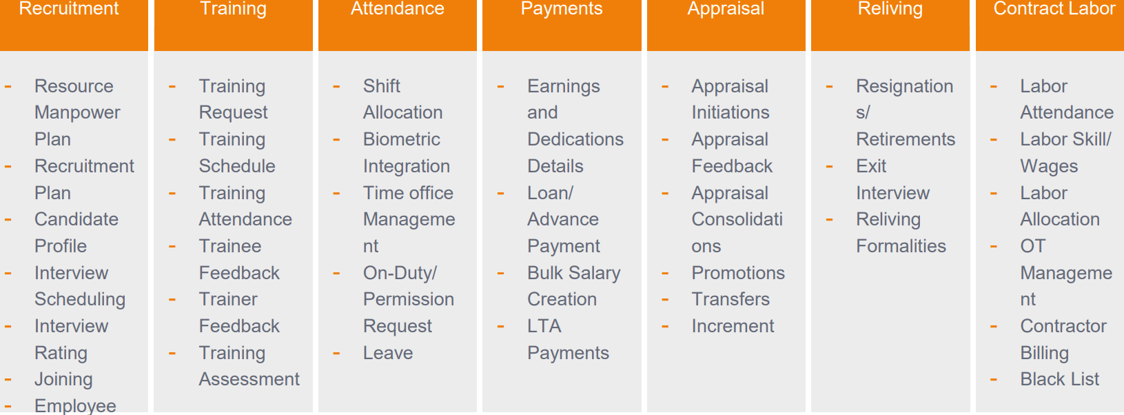

**Human resource planning**

In a software house, there are three inputs to the human resource planning process:

1. Human resource plans from existing projects, showing how many staff of each grade and with which specialized skills will be required in each of the following months.
2. Sales forecasts: These are subject both to the unexpected behaviour of potential clients and the judgement, good or otherwise, of the sales staff.
3. Forecasts of the likely staff losses in the coming months: In the software business this depends very much on the buoyancy of the market for software developers.

**Job Design**

Setting up an organizational structure implies designing jobs. As soon as a one-person organization becomes a two-person organization, it has to decide who does what; in other words, it has to design jobs.

**Job rotation**: is rotating staff through series of jobs, is the most obvious way of preventing employees from becoming bored with a very narrow and specialized task.

**Job enlargement:** It adds variety and interest, and may increase pride in job. It may not be consistent with separation of responsibilities in financial matters.

**Job enrichment:** Job enrichment means adding more responsibilities, to say, Julie’s job.

**Software contracts and liability**

**What is a *Contract*?**

A *Contract* is an agreement between two parties that creates an obligation to perform (or not to perform) a particular duty.

A legally enforceable contract requires:

1. An Offer *(I’ll mow your lawn this weekend, if you pay me $30)*

2. An Acceptance *(You’ve got a deal)*

. **What is essential is:**

* all the parties must intend to make a contract;
* all the parties must be competent to make a contract, that is, they must be old enough and of sufficiently sound mind to understand what they are doing;
* there must be a ‘consideration’, that is, each party must be receiving something and providing something.

**Drafting Contracts**

**A Contract Must be:**

**1:** Made in a Clear and logical manner **2:** Complete and consistent **3:** Clear from ambiguity

**Software Engineers deal with different types of contracts like:**

**1:** Insurance **2:** Employment **3:** Suppliers **4:** Consultancy etc.

**Structure of Contract must have:**

**1:** A short introductory section **2:** What is to be produced

**3:** What is to be delivered (as Annexes) **3:** Ownership of rights (License and exclusive license)

**What is to be produced**

**There are usually two levels of reference here:**

1. the standard terms and conditions refer to an annex
2. The annex then refers to a separate document which constitutes the requirements specification

**Ownership**

**It is important for the contract to state precisely who is to own these rights.**

* Software is potentially protectable by a number of intellectual property rights, such as copyright, design rights, confidentiality and trademarks.
* If the person who creates the software is an employee acting in the course of employment, the copyright belongs to the employer.
* Ownership in copyright is passed only by written assignment or transfer
* If ownership of copyright passes to the client it is known **as a sale or assignment** and a written agreement is necessary.
* If copyright is to remain with the software house and the client is merely given permission to use the software, this is known as a **license**.
* It can be an exclusive license as well.

**Granting of license**

* Duration of license (Period of license and termination method)
* Transfer of license
* Scope of license (One computer, one site (e.g., campus))
* Confidentiality (Cannot allow anyone but employees to use it)

**Payment Terms**

* Time limit needs to be addressed.
* Payments must be made in specified times, otherwise, ‘x’ amount of interest may apply.
* Payment made all at once or pay different amounts throughout the duration.

**Delays/ changes**

* The contract needs to have annex terms for rates.
* Charges for delays will be calculated using these terms.
* Delayed payments and payments for variations to the original requirements are, perhaps, **the commonest cause of contractual disputes.**

**Standards and methods of working**

**1:** Arraigning Progress meeting **2:** Meetings with Project managers

**3:** What will be the Acceptance procedure **4:** Warranty and maintenance

**Standards and methods of working**

**1:** Termination of contract **2:** Arbitration: is a technique for the resolution of disputes outside the courts.

**3:** Inflation **4:** Applicable law

**site license**: A license may allow the licensee to run as many copies of the software as he wishes on computers at specified premises.

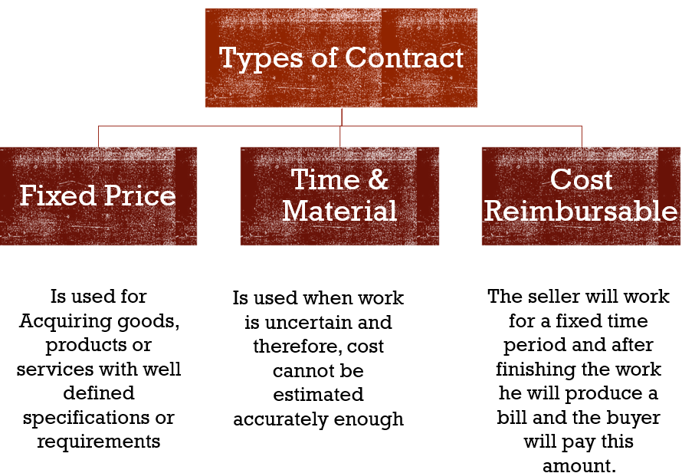

**ADVANTAGES** of fixed price contracts include throwing all the risk on the seller.

**Contract hire**

* Supplier’s responsibility is limited to providing suitably competent people and replacing them if they become unavailable.
* The staff work under the direction of the client.
* Payment is on the basis of a fixed rate for each day worked.
* Ownership of intellectual property rights generated in the course of the work may need to be addressed.

**Time and Materials (hybrid)**

* In this type of contract, payment is made on the basis of the costs incurred, with labor charged in the same way as for contract hire.
* This is somewhere between a contract hire agreement and a fixed price contract.
* This contract is usually used when **requirements of the project are not clear enough as to allow a fixed price,** or usually when hardware is also required.

**Consultancy**

* The outcome of a consultancy project is usually a report or any other related document.
* Under normal circumstances a fee for IT consulting is assessed on a per day, per consultancy basis.
* Fixed fee IT consulting contract applies to projects which are well defined.
* Open ended consultancy contract generally favors the consulting firm, as the consultancy firm charges on a per day basis, **there is no incentive to complete the task within a fixed period.** This increases the risk of project completion and cost overrun, but the contract is very simple. (DA)

**Four important aspects of a consultancy contract**

* **Confidentiality:** Consultants may learn about client’s confidential information.
* **Terms of reference:** What reports/ workflows etc. the consultant might need to refer to. Issues arise when matters which were not considered beforehand may be needed to be addressed.
* **Liability:** How to decide liability on an advice?
* **Final report acceptance:** Usually a draft version before the final product.

**Outsourcing**

Obtain (goods or a service) by contract from an outside supplier

* Sometimes known as *facilities management*.
* Company or organization (the customer) hands Professional Issues in Information Technology over the planning, management and operation of certain functions to another organization (the supplier).

IT outsourcing contracts are inherently complex and depend very much on individual circumstances.

**Some important points to consider:**

* + How the performance to be monitored and managed;
  + What happens if performance is unsatisfactory;
  + Which assets are being transferred;
  + Staff transfers;
  + Audit rights;
  + Contingency planning and disaster recovery;
  + Intellectual property rights in software developed during the contract;
  + Duration of the agreement and termination provisions.

**Cost Reimbursable Contracts:**

* The name is self-explanatory here. The seller will work for a fixed time period and after finishing the work he will produce a bill and the buyer will pay this amount.
* This is almost negative for a buyer. A seller may charge an unknown amount which the buyer has to pay. The seller is at advantage in this contract, not the buyer. That’s the reason this type of contract is **rarely** used in the real world.

**Some important things to consider**

* Limiting the extent to which the customer can use the software, so that if the customer wants to use it more extensively, he must pay an additional license fee;
* Ensuring a regular income from support activities, possibly an annual maintenance charge, possibly fees for consultancy services;
* Ensuring that, as far as is possible, it will not be liable for any defects in the software.

**LIABILITY FOR DEFECTIVE SOFTWARE**

* Suppliers of software and hardware are very reluctant to give a contractual commitment that it is fit for any purpose whatsoever.
* Standard terms and conditions will invariably contain a clause that tries to limit the supplier's liability if it turns out that the software or hardware is defective.
* The law, however, limits how far such clauses can be effective.
* Most contracts will limit the extent of any liability either to the purchase price of the product or to some fixed maximum figure.
* This means that, if the product completely fails to work, the supplier agrees to refund the purchase price or possibly a bit more if some other maximum is specified.
* The Unfair Contract Terms Act 1977 restricts the extent to which clauses in standard terms and conditions limiting liability can be effective.

**HEALTH AND SAFETY**

The Health and Safety at Work Act (1974) states: ‘It shall be the duty of every employer to ensure the health, safety and welfare at work of all his employees.’

It breaks this duty up into a number of more specific tasks. The ones that are of particular concern to software engineers are:

* provision and maintenance of safe plant;
* provision and maintenance of safe systems of work;
* provision of such information, instruction, training, and supervision as necessary;
* ensuring the workplace is maintained in a safe condition;
* provision and maintenance of a safe working environment and adequate welfare arrangements.

1: The Act also requires employers to ensure that their activities do not expose the general public to risks to their health and safety. Manufacturers of equipment to be used at work also have a responsibility to ensure that it is safe.

2: Failure to comply with the Health and Safety at Work Act is a criminal offence and, in serious cases, can lead to criminal proceedings being taken against individuals.

3: Trains, ships and airplanes are all places where people work and where the general public are present.

4: The safety obligations listed above therefore apply to them. Furthermore, they all involve equipment that is controlled by software and accidents may occur as a result of defects in that software.

5: Modern manufacturing plants are usually software controlled and can be dangerous; robots in particular can be dangerous for people working with them.

6: Modern chemical plants, oil refineries, and power stations, especially nuclear ones, are all software controlled & software failures can result in accidents that affect not only the workforce but also the general public.